**File Creation Task**

1. Create a directory called ""my_folder"", navigate into it, and create a file named ""my_file.txt"" with some text. Then, create another file named ""another_file.txt"" with some text. Concatenate the content of ""another_file.txt"" to ""my_file.txt"" and display the updated content. Finally, list all files and directories in the current directory.
2. Create a directory in Linux server. Used below mentioned command.

**mkdir my_folder**

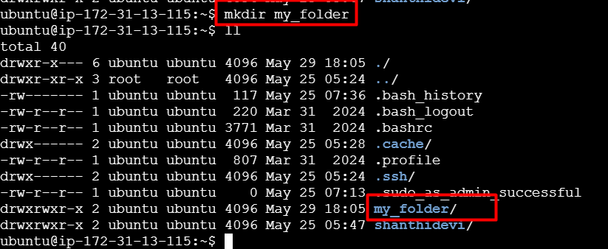

Create a file with some text and Used touch command. Open my_file.txt with vi command.

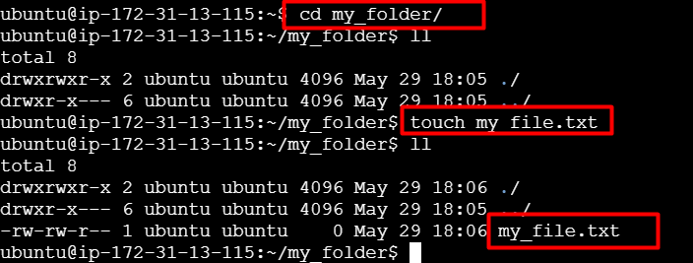

Insert some text in my_file.txt file. Used insert command and press ESC and save the file us :wq command in my_file.txt file. 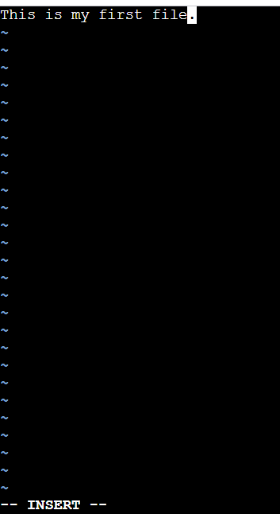

checked cat command to see my content of the file.



Create a file with some text and Used touch command. Open another_file.txt with vi command.

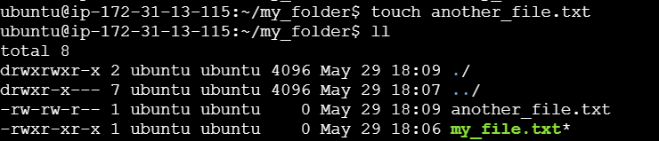

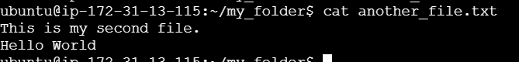

Concatenate the content of ""another_file.txt"" to ""my_file.txt"". This command only changed in my_file.txt file only.

**cat another_file.txt >> my_file.txt**

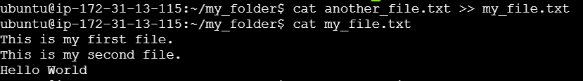

Finally, list all files and directories in the current directory.

**ll - list the directory**

**PWD- check the current path.**

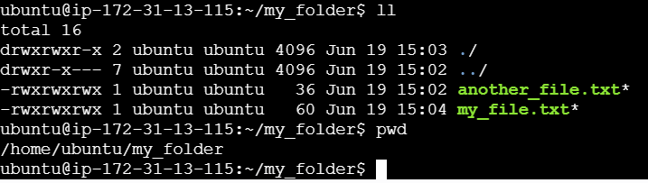

**2. Create 20 files with .txt extensions and rename the first 5 files to .yml extension and Print the latest created top 5 files among the total no of files".**

Create 20 files with .txt extension. Used below mentioned command

**touch file{1..20}.txt**

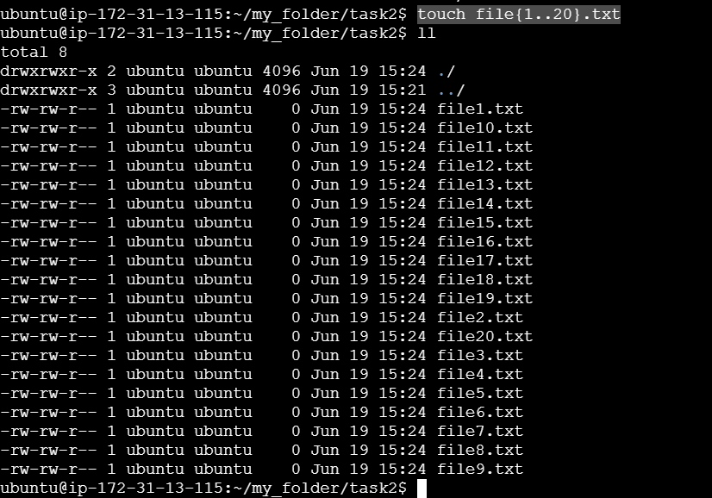

Rename the first 5 files to .yml extension. Use below mentioned command.  
**mv file1.txt file1.yml**

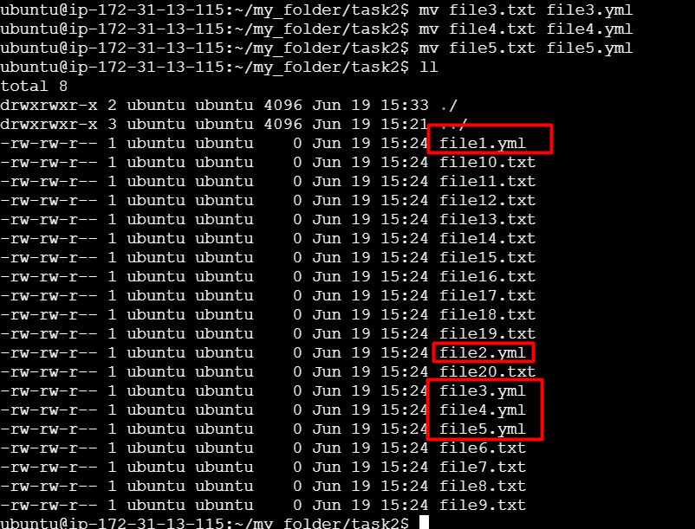

Print the latest created top 5 files among the total no of files. Used below command

**ls -lt *.txt | head -n 5**

**ls -lt: Lists all files sorted by modification time, newest first.  
head -n 5: Displays the top 5 latest files**

